EDIWHEEL
WORKORDER

Table of Content

What is EDIWHEEL WORKORDER? 3
What are the use cases? 4
What is the process? 4
How does it work? 5
Each Web Service in practice 6
Authentication 6
GET contracts 6
GET vehicles 6
POST/GET workOrder 6
GET workOrder/status 7
POST/PUT/GET/DELETE attachments 7
Codelists 8
Master Data and mappings 8

What is EDIWHEEL WORKORDER?

EDIWHEEL WORKORDER is the standardization of System-To-System format around the work order / job sheet.
This is a set of API Web services which will allow communication between Tire Maintenance Service providers (SP), Tire Manufacturer (TM) as Contractors, and Customers around Vehicle and Tire maintenance.
EDIWHEEL WORKORDER doesn’t standardize the processes between TM and the content of each message will have to be agreed between SP and TM. The way to communicate it is standardized.

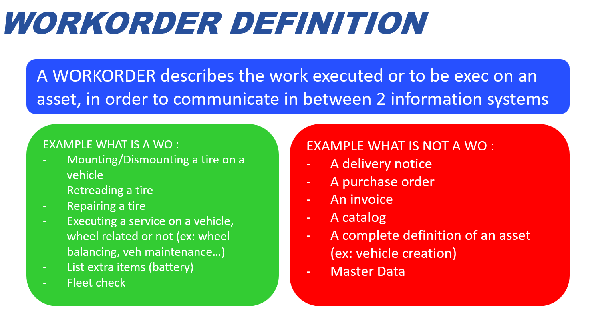

What are the use cases?

MVP1 (2024) is leveraging communication from Service Providers to Contractors:
- SP will be able to identify if a vehicle is under contract with a TM
- Then, get all needed data of the vehicle (config, mounted tires…)
- And finally send a Work Order executed or to be executed to the TM
- SP will also be able to get status updates from the TM
- And send documents (proof of work, pictures, signature…)

The schema below describes the potential sequence of API web services call.
Of course, if SP already knows the contract and vehicle, he can POST a WO directly.

What is the process?
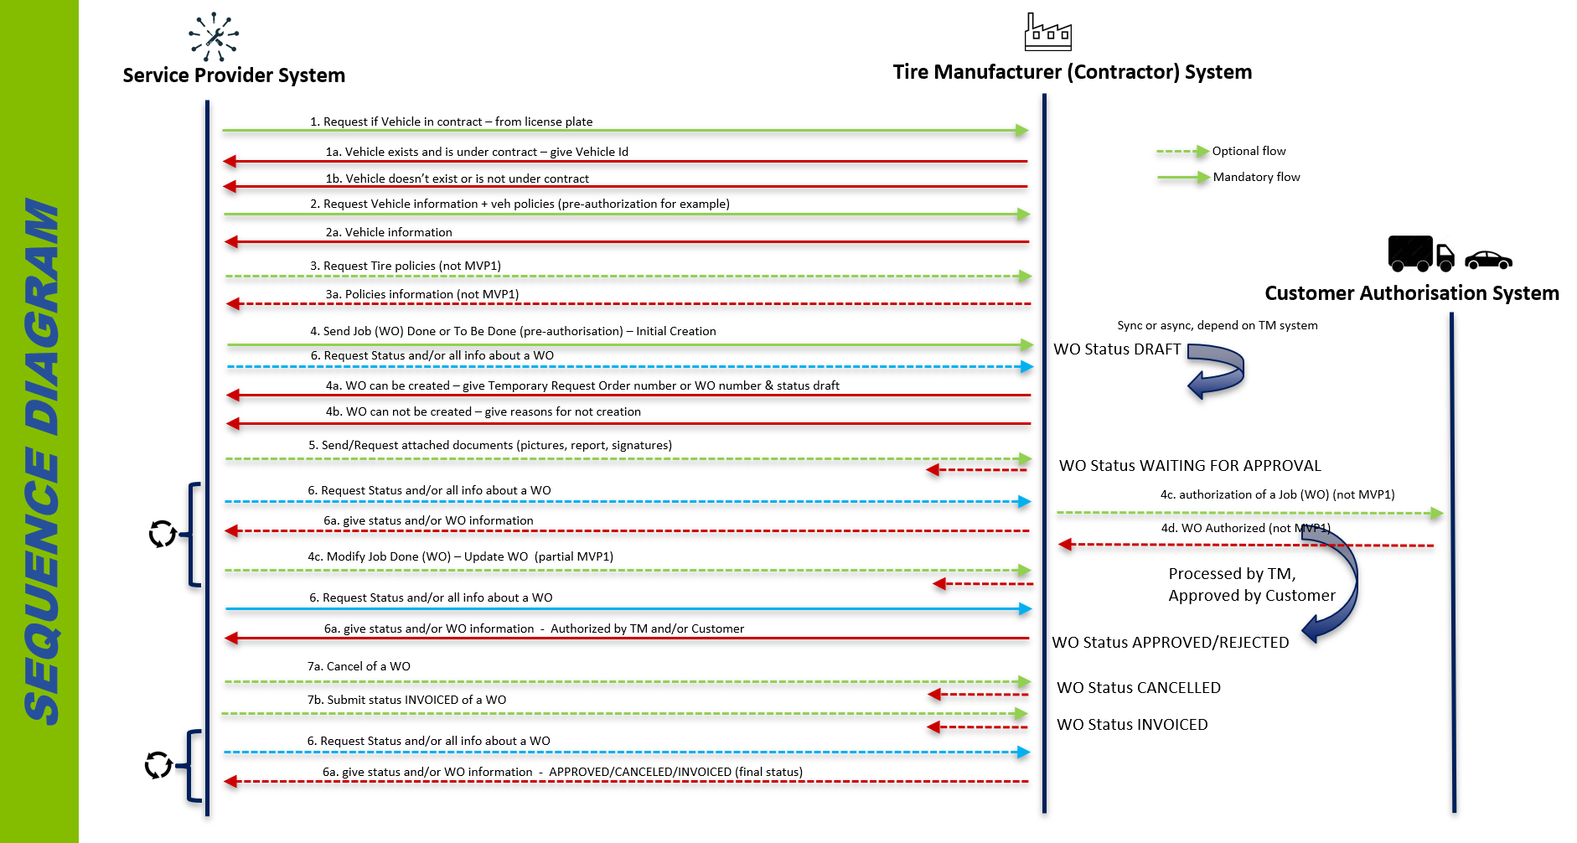

How does it work?

EDIWHEEL WORKORDER proposes a library of web services that allow the process described in previous chapter.
These are just described standard formats.
There is no central unique API (such as GDSO). Corresponding API will have to be developed and exposed by Contractors, respecting the standard format.
Format is detailed in the OpenAPI documentation available on EDIWHEEL web site.
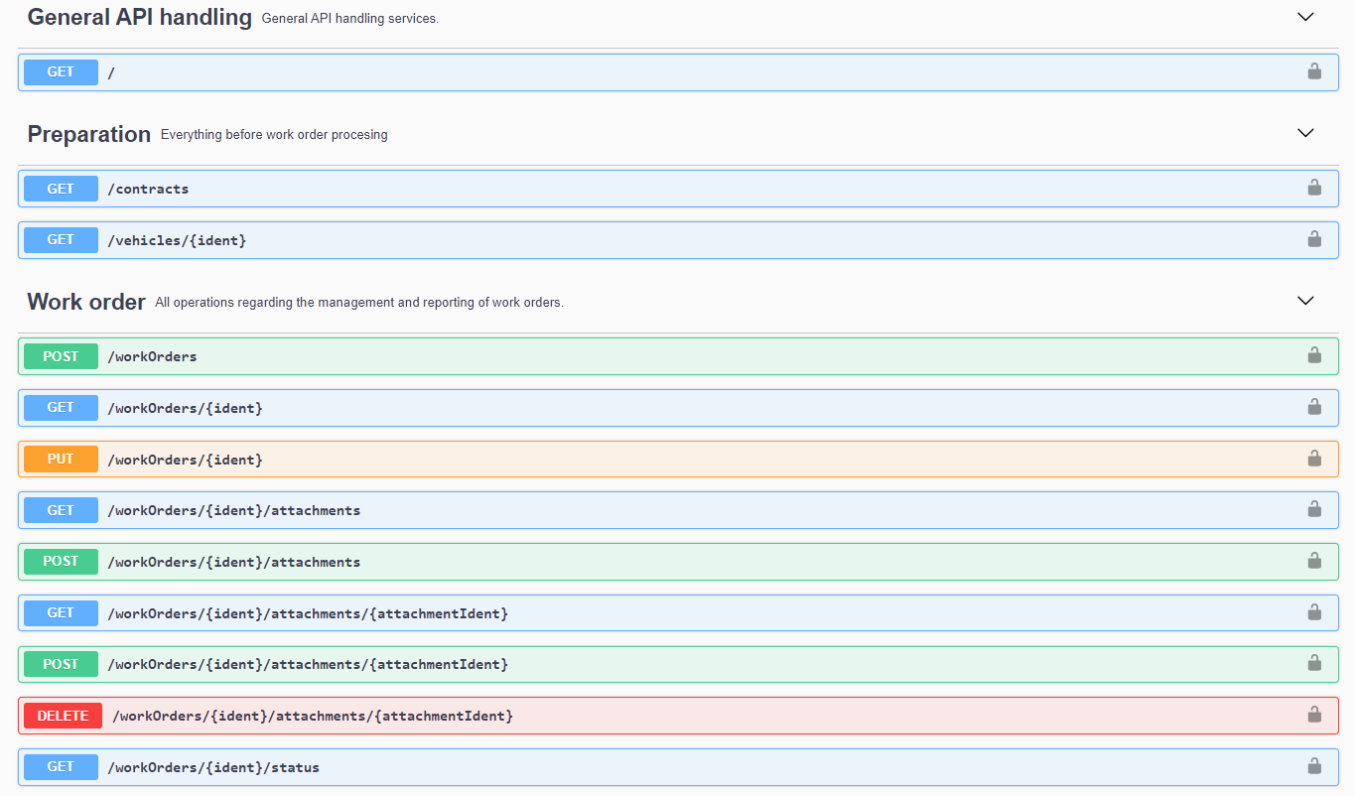

Each Web Service in practice

Authentication

Authentication service is under each API Producer responsibility. There is no standard pushed by EDIWHEEL. However Oauth2 is a good practice in general.

GET contracts

This web service allows the SP to ask TM if a vehicle is under contract, based on a vehicle identifier (VIN, license plate of fleet number).
If the vehicle is recognized and under contract on TM side, this web service will respond the id of the vehicle in the TM’s context (it will be used later).

GET vehicles

This web service allows the SP to ask TM the details of a vehicle:
- Type
- Brand, model, year…
- License-plate, fleet number…
- Vehicle configuration (axles, positions, mounted tires)
- Mounted tires (By position)
- Last known measurements (By position)
- Current Open defects (By position)
The scope of Data a TM will answer may vary depending on the implementation.

POST/GET workOrder

This is obviously the main and biggest web service of the WO library.
It allows the SP to send a work order to a TM and/or to get content.
It describes the content of a WO:
- WO references (identifiers, references, PO numbers… from party systems or from billing…)
- WO Type (Inspection, Job execution, breakdown…) and STATUS
- WO Events date and time (requested, planned, deadline, actual, start, end…)
- WO Parties (Service Provider / Service Center, customer whom the asset belong to…)
- WO Actors (role, name, phone)
- WO Assets information (type, identifiers) : vehicle, tires…
- WO Intervention location
- WO Remarks (comments…)
- WO lines (one line per product/service/operation):
  - Line identifier, quantity, comment
  - Link to asset (if relevant. Eg vehicle, position)
  - Product/service (1 by line)
  - Measurements
  - Prices
  - Observations/Defects
  - Mount/Dismount/Rotate/Regroove additional informations

GET workOrder/status

This web service is a subset of the GET workOrder.
It allows the SP to get the status of a WO.
It can be used on asynchronous processes (authorization for example) to update the SP system on a regular basis. Batch frequency may be defined with each implementation.
The schema below describes the statuses and transitions.
The status transitions may be business dependent. It has to be agreed with the TM.
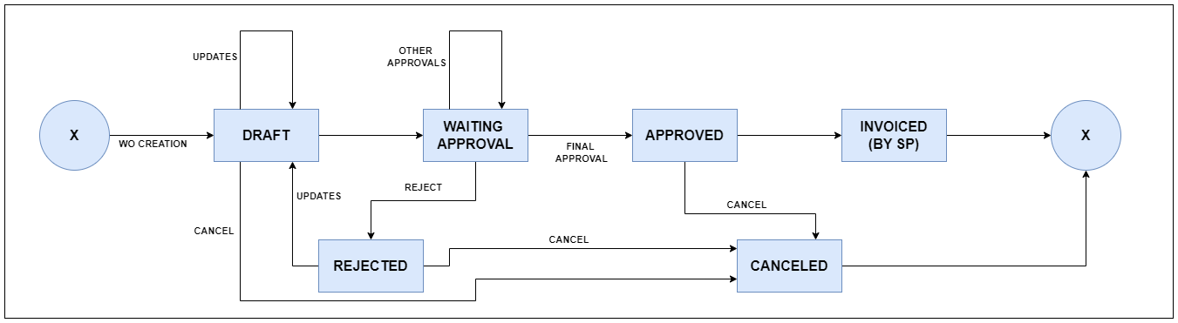

POST/PUT/GET/DELETE attachments

Thes web services are a subset of the workOrder.
They allow the SP to send or link documents to a WO (pictures, scanned paper worksheet, signature…).
Only some media types are supported, they are described in the technical documentation.

Codelists

Formats of web services have been designed to be generic.
It avoids specific name (example serviceStartDate and serviceEndDate) and promotes generic type+value fields (example type = serviceStartDate and value = 01/01/2024).
All these types are organized in codelists, grouped by categories.
Codelists are part of the standard format and available in the technical documentation.

Master Data and mappings

Some data are specific to a TM, for example the list of service references of its catalog or the list of defects, observations, recommended actions.
This is called Master Data.
There is no standard Master Data, and mappings will have to be done from SP Data to each Contractor data.
By default the replied or accepted language is English. As an option, you may agree in between API Consumer and API Producer, on some Business Data Mapping and so send in local language.

